We endeavour to ensure that the following facilities are available and regularly stock-take to check that. However, we are not able to guarantee that all such facilities and supplies will always be available and in full working order as shortages and damage may have occurred during a previous hire and not reported.

- SUMMARY OF FACILITIES

Defibrillator

Note that the Hall has a defibrillator which is mounted on the external west wall of the building clearly signed from the car park. No special training is required to use this equipment which automatically provides voice instructions once the unlocked and lit cabinet is opened.

Fire Alarm in Foyer

- This is not connected to a fire station or the police
- If the alarm rings, evacuate the Hall (Fire Risk Assessment, DN8 for more information)
- Call fire service/police from a mobile phone (dial 999)
- Can be reset using the key (on ring with hall entry key)
- Check that the fire exit signs are illuminated (for a Hire extending outside of daylight hours).

Store-room

- Sufficient tables and chairs on racks for a seated meal for 120 people
- Demountable stage units on racks (see DN27 for assembly instruction)
- Lockable cabinets for equipment for Interest Groups
- Cleaning room at end of storeroom with all equipment needed for Hirers to clean up after use
- Table tennis tables for the exclusive use of the Table Tennis Group (not for use by general hirers).

Please store all equipment back as-found. Tables to be distributed on the trolleys as per the instructions on each trolley, so that the trollies do not fall over. Tables are not heavy but may need to be moved by more than one person. Chairs should not be stacked more than 25 high to avoid them falling over. A special lever is provided, hanging up in the Storeroom, for closing the tables – see photo overpage:

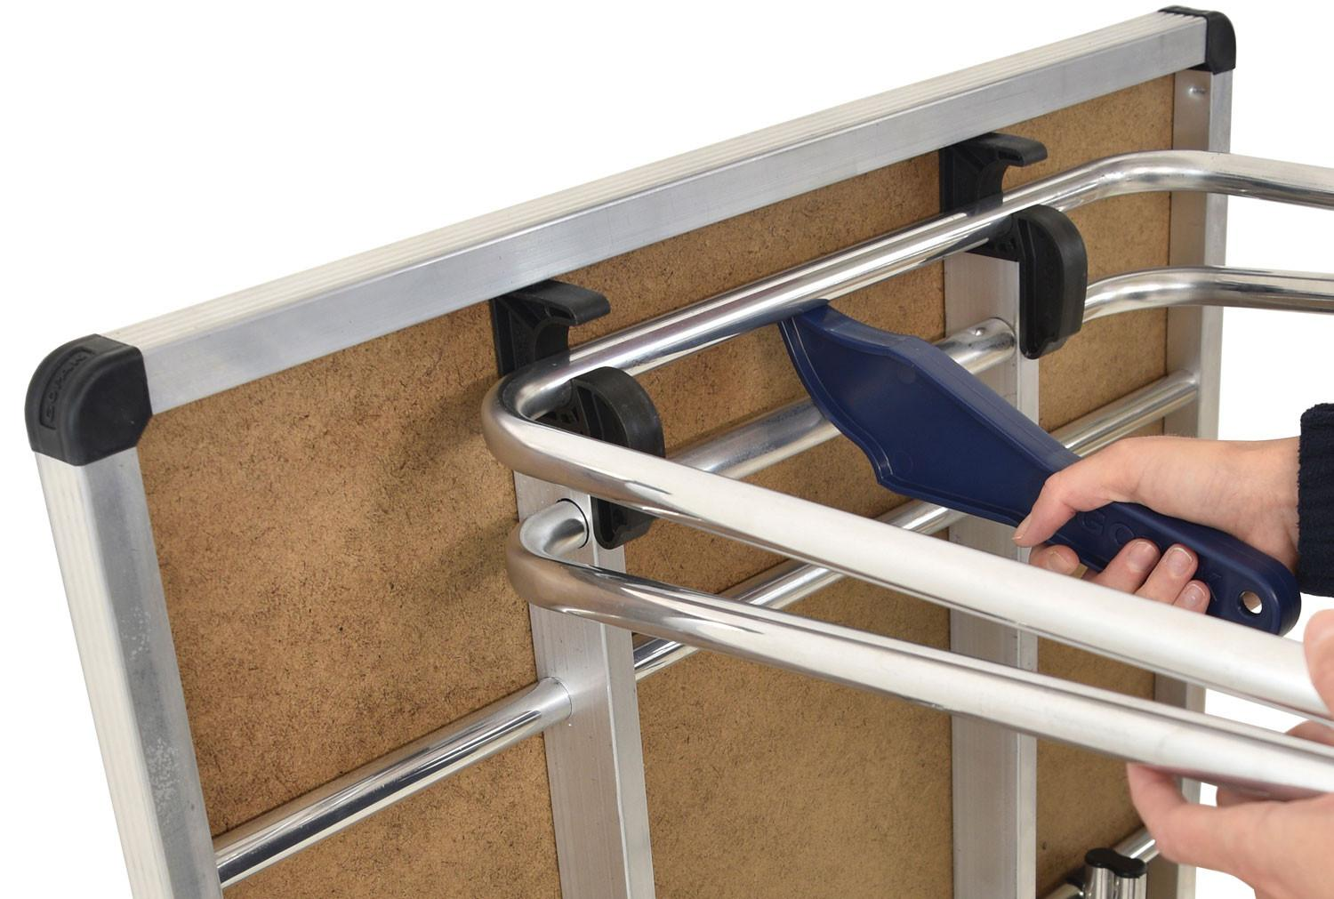

Kitchen

- Water heater - plumbed in - turn on (switch above small sink) – supply of water in 15 minutes

Note - The hall’s hot water makes use of a small hot water tank that is heated when switched on in the kitchen. The amount of water in this tank should be sufficient for all events, but to ensure that the supply of hot water doesn’t run out during your hire we advise that it is used conservatively. Therefore, when washing dishes etc., please do so in a sink full of warm water and making use of the plug, rather than washing under a constantly running tap.

- Oven - large switch on wall to turn on appliance
- Warming oven (isolation switch above)
- Two fridges (each with a thermometer)
- 50 mugs
- 50 cups and saucers
- 50 dinner plates
- 50 side plates
- 50 bowls
- 50 pint glasses
- 50 glass tumblers
- 50 cutlery place settings
- 50 champagne flutes
- 50 Parish goblets
- 20 small plastic mugs for children
- Assorted catering equipment, if important then visit Hall first to check what is available. Note that there are only a couple of potentially dangerous implements kept in the kitchen and so Hirers who may need sharp knives, skewers, meat tenderizer etc should bring these and take them away at the end of the hire.
- All cutting must be done on cutting boards and not the work surfaces
- Supply of clean tea towels and dish-clothes (to left of dishwasher) which are for use for a single event and should then be left in the laundry bin for professional cleaning
- Dishwasher which has a short cycle (instructions above it on the wall)
- First aid kit, which contains the following items listed on following page
- Accident Record Book – kept with First Aid Kit
- Safety shutter for hatch - if fire alarm goes this will come down automatically
- Fire blankets x 2
- Three waste bins, clearly labelled, recycling, non-recycling and glass.

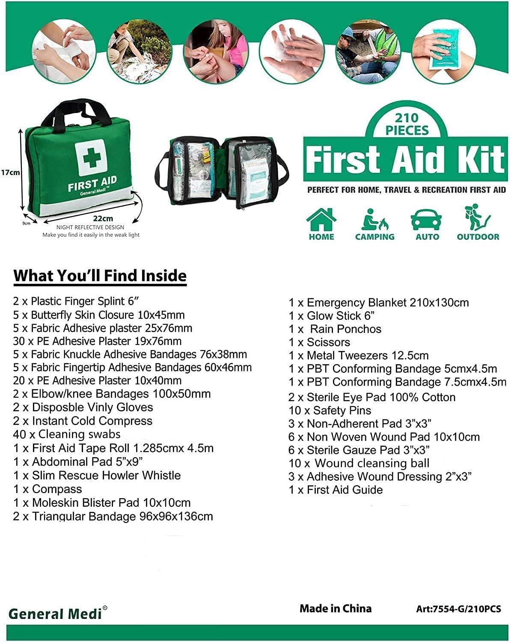

Grundon Waste Bins – in the bin store in the car park.
These are illuminated at night which is activated by a proximity detector. The simplest route is out the door from the storeroom, rather than the front door. The digital padlock on the bin store has the same combination at the key box. Remember to lock the storeroom exit door if you do use it.

General Waste Bin (including food waste)
This is a circular chrome bin which should be lined with a black plastic bag (supply kept under sink) and the black bag should be emptied at the end of the hire into the Commercial (Grundon) blue bin in the bin store in the car park. The black bag, unless it is contaminated, should then be replaced in the chrome bin so that we recycle as much as possible.

Recyclable Waste Bin
This is a circular chrome bin which should be lined with a clear plastic bag (supply kept under sink) and the clear bag should be emptied at the end of the hire into the Recycled Green Waste (Grundon) bin in the bin store in the car park. The clear bag, unless contaminated, should then be replaced in the chrome bin so that we recycle as much as possible. This includes paper, card, drinks cans, and plastics.

Glass Waste Bin
This is a plastic bin in the kitchen which should be unlined and should be emptied at the end of the hire into the black Glass Waste (Grundon) bin in the bin store in the car park.

- Spare plastic bags (black for general, sanitary and food waste and clear for recycled waste), washing up liquid are kept under the sink.
- Separate bin for laundry, which will be professionally cleaned.

Note that for the protection of children the following precautions are to be taken:

- No chemicals should be kept in the kitchen but are held in a separate locked cupboard (accessible only to our cleaners) and so not available to Hirers
- Hence Hirers should only clean with warm water and washing up liquid;
- Children (aged under 16) are not allowed in the kitchen;
- The kitchen door should be kept locked when not in use.

Main Hall

- Electrically operated vents at high level can be opened if Hall gets too hot. Remember to close when leaving.
- The connecting doors to the foyer are fire doors and will close automatically in the event of a fire. Similarly, the shutter to the serving hatch.
- The fire doors to the Storeroom should be kept closed when not in use.

Foyer/Entrance Hall

- There is a wall mounted video display for use for a computer presentation for meetings. There is no computer. The Hall holds a TV license. There is an HDMI cable attached to the back of the TV, and a multisocket mains extension cable.
- The noticeboards and strategically placed notices contain essential safety and operational information and should be referred to by Hirers at the commencement of an event.

2 FIRE SAFETY AND HSE OBLIGATIONS

As the responsible person for hiring the hall, you have legal duties with regard to the safety of people attending the event:

Before the event or function, you must familiarize yourself with the Fire Risk Assessment, escape plan, and the HSE Risk Assessment displayed on the Village Website and use the check-list below.

You should advise your guests of essential safety information and action to take in the event of a fire.

What not to do

Hirers should not:

- Prop fire doors or use wedges to hold them open. 95% of people killed in fires are killed by smoke, so closing fire doors is vitally important.
- Do Not Let Rubbish accumulate, clean as you go.
- Block fire escape routes.
- Smoke.
- Bring untested portable electrical appliances to the Hall.
- Cook using deep fat frying.
- Try to fight a fire if that creates personal risk
- Bring and leave any combustible material into the Hall other than by prior arrangement with the Trust.
- Bring candles or naked flames into the Hall, this includes flame-based food warmers.
- Let children in the kitchen and the kitchen door should be kept locked when not in use. The Hirers key will open the Kitchen door.
- Let children in the Plant Room (accessible from the Storage Room) and the Plant Room door should be kept locked when not in use. The Hirer’s key will open the Plant Room door, which will be necessary to turn on or off the utilities.
- Stick or otherwise fix anything to the timber floor or any of the walls.
- Allow smoking within 10m from the external timber walls (which are combustible). If there are smokers then place cigarette buts in external wall-mounted but bins.
- Allow any cooking appliances (other than in the kitchen) within 10m of the external walls. Barbecues should not be used and any cooking should take place only in the kitchen.
- Trailing cables in public areas must be covered with cable covers.

Special Risk Assessment Requirements

The Risk Assessments referred to herein and prepared by the Trust cover all general users of the Hall and have been prepared by the Trustees based on their assessment of the general risk. It is the responsibility of Hirers to identify any special risks associated with their activities carried out in the Hall (or on the Playing Fields and Tennis Court) that may not be covered by the general risk assessments and ensure that the participants in those activities are safe. The Trust asks Hirers who identify any risks not covered by the Trust’s risk assessments to advise the Trust so that the Trust’s own risk assessment can be revised if appropriate.

It is the Hirers responsibility to ensure the safety of children at all times both within the Hall and in any external areas associated with the Hall.

- CLEANING

At the end of the Hire all used areas should be checked and if necessary cleaned. Floors should first be swept, or vacuumed, and further cleaned if still dirty. Use the labelled mist mop on the wood floor. Any spillage on the stone and vinyl floors should be wiped using the sponge mop and water. Clear any debris outside the Hall associated with your use.

LEAVE THE HALL AS YOU WOULD WISH TO FIND IT.

- OTHER INFORMATION

4.1 Accessing the hall and car park

Normally access to the hall will be by a master key from the digital key safe by the front door. The Booking Manager can advise the current code. The distance between the bollards is enough for 99% of cars but one can be removed, the digital padlock on the bollards has the same combination as the above key box.

4.2 “On Call”

Any questions from Hirers should in the first instance be directed to our Booking Manager.

Phone: 07536 173356

If our Booking Manager is asked to arrange a visit by a Hirer and that visit is for reasons other than a defect in the Hall, then a call-out charge is to be borne by the Hirer.
The contact details for the Trust Chairman (Helen Stradling) are:
Mobile 07775801130

4.3 Sanitary Waste disposal

There are lined bins within each of the lady’s toilets and the disabled toilets for the disposal of used nappies and sanitary products. At the end of each hire please dispose of these sanitary products in the Commercial (Grundon) bin in the bin store in the car park, and replace the bin liner with new from under the sink in the kitchen.

  - Waste Recycling

There is good provision for waste recycling in the appropriate waste bin in the Hall Kitchen, and into the Commercial (Grundon) bin in the bin store in the car park. The digital padlock on the bin store has the same combination at the key box.

We are a community facility and not a commercial business. We do not have cleaning between hires so please leave the Hall for the next hirer in the state you would expect to find it, or better. Thank you.

- HIRER’S CHECK-LIST

Refer to BVH DN5 – C for a template of a Hirer’s check-list the provisions of which form part of the Hire Agreement.

